Algorithmic Search in Health Records

David Graves
Colorado State University Global
CSC506
Dr. Brian Holbert
March 31, 2025

Algorithmic Search in Health Records
There are many types of algorithms one can use when attempting to search or manipulate entries within a given database. Often the chance of the successful execution of the program is defined early on when decisions are made regarding what type of algorithm should be used to help solve a particular problem. Healthcare presents unique challenges when tracking, connecting, and delivering coherent hospital patient records, making it a good space where algorithms can be positively leveraged. Their proper use in this space can help eliminate confusion, create better customer experiences, and can directly affect the care one gets while in the hospital that could lead to proper diagnosis and corresponding outcome. For those as well as other reasons it is important that a good algorithmic solution be implemented when dealing with this population of data. Two options that one could consider for this use case are Bubble Sort and Merge Sort algorithms. I'll use the remainder of this paper to compare both the Bubble Sort and Merge Sort Algorithms to understand their efficacy as solutions for enhancing the efficiency of a hospital's patient records. I'll analyze the time complexity of both and share the conditions where they perform well when considering the inherent problem of sorting in healthcare.
Algorithm Design and Purpose
One of the critical problems across healthcare is the vast array of inputs that administrative organizations must incorporate to build a robust and complete picture of each patient. There are so many different software systems that have critical data including claims, payments, procedures, provider data, and other medical history that it’s difficult to have consistent reliable data that is relatable and comparable. This presents unique challenges where, “a lack of data quality was shown to present obstacles for smooth operations, result(ing) in financial losses, and contribute(d) to medial errors” (Zhang & Callaghan-Koru & Koru, 2024) as shared last year via the National Library of Medicine. With that in mind, both Bubble Sort and Merge Sort algorithms rely on a good starting data set and are only as good as their input. They can’t solve data quality as an input, but putting that aside, let’s look at how each one would perform with a quality data set. Bubble sort which “takes an iterative approach looping through elements in a matrix like fashion” (Tutu, 2016) works by starting at the beginning of an array, compares two elements and swaps them according to value. Ultimately the smallest numbers move to the front of the list with every iteration until we end up with a sorted list. Provided the same input, we will also end up with the same output list using Merge Sort in place of Bubble sort. The Merge Sort algorithm gets there differently though by breaking the problem down into smaller tuple-sized subarrays, sorting, then merging back together as a whole. As explained, both produce the same result so what’s the difference. In looking at time complexity we can start to see that Bubble Sort becomes less efficient the larger the data set is. The time complexity of Bubble Sort is O(n) with a sorted array and with an unsorted array has a worst-case scenario of O(n)^2, whereas Merge Sort has a consistent time complexity of O(n log(n)) regardless of the array’s original form and performs more efficiently in comparison as the data set grows larger. Given the complexity and the unstructured nature of incoming data in the health field the proper choice should be Merge Sort. I’ve included images below of both a Bubble Sort Algorithm (Image 1) and a Merge Sort Algorithm (Image 2) as examples of working programs put to the task of sorting the same array.

Image 1 (Bubble Sort Algorithm and Output)


Image 2 (Merge Sort Algorithm and Output)
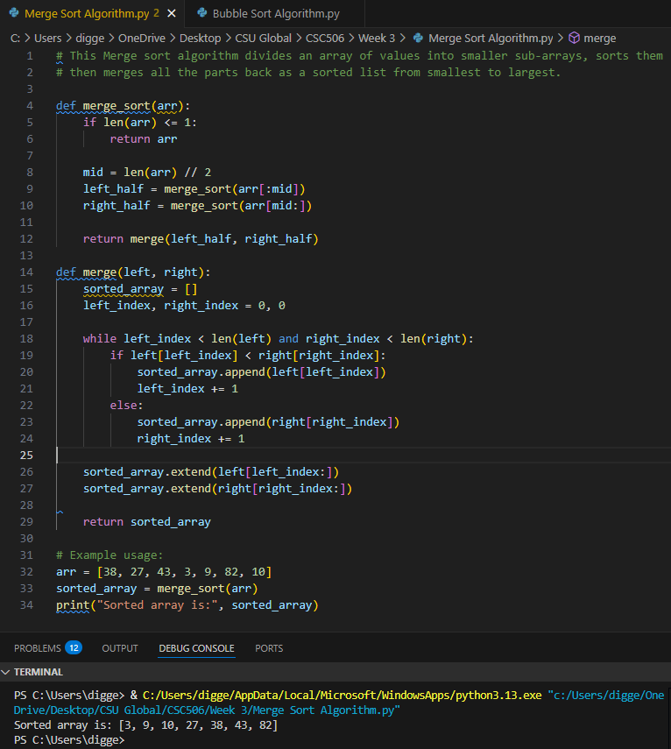

Reflection
This exercise provided a good entry for me to understand time complexity and how the structure of the data to be sorted plays a part in the execution of specific algorithms. In drafting and implementing both a Bubble Sort and Merge Sort algorithm I was able to take what I conceptually understood and translate that into material work. By using a real-world problem like healthcare records reinforced the challenges of sorting disparate and sometimes scattered data into one cohesive unit that can be better understood and optimized for patient outcome. Although these programs were both basic and implemented on small data sets it’s clear to see and understand how Merge Sort would be much more efficient as the number of records in an array grows in complexity and size.

References
Tutu, AnnMargaret (2016, November 15). Medium.com. Sorting Algorithms: The Difference
Between Bubble Sort and Merge Sort.
https://codeamt.medium.com/sorting-algorithms-the-difference-between-bubble-sort-and-merge-sort-bc91c3c2aff1
Zhang, Yili & Callaghan-Koru, Jennifer A & Koru, Gunes (2024, August 1).
pmc.ncbi.nlm.nih.gov. The challenges and opportunities of continuous data quality improvement for healthcare administration data.
https://pmc.ncbi.nlm.nih.gov/articles/PMC11293638/

